Project 2

Title:

Dungeon Crawler Version 2

Student: Hassan Farhat

Submitted to Professor Mark Lehr

Due Date: 13th December, 2016

Course and Section:

CSC-5, 48102

1. **Introduction:**

Dungeon crawler was created to honor previous Dungeon crawling games. Dungeon Crawler Version 2 builds on the concepts of its predecessor. It follows the same goal; traverse a dangerous dungeon and defeat the boss at its end.

The game can be thought of in 4 parts:

Character Creation  
 Shop  
 Movement and map control  
 Battle Sequences

Each one of these existed in the previous game however they all received some form of overhauls. In summery; all of them received functions, many received arrays, and the battle and map were completely rewritten.

The purpose of these changes was to express the concepts of the class and to make the game more efficient and cut away bloated code. The result allowed me to add more features to the game that both made it more interesting.

A deeper look into the changes will be examined when I discus the important parts of the code.

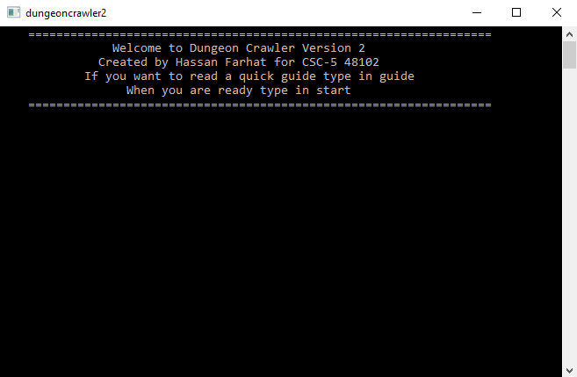

1. **Gameplay:**

The overall game-play of the game is very similar to its predecessor.

The game starts with an intro screen. The player may start the game directly by typing in “start”, or they can type in guide to read a quick guide about how the new class system works.

After that, the player will be asked to select their class. (The importance will be discussed later). Then the player will decide how to distribute points into their individual skills; essentially determining what their character is best at.

The player is then presented with the first shop in which they can buy items. There are 7 to choose from, each will give the player certain advantages.

When the player is done with all that set up its time for the main section of the game to start. The player can now move, by typing in the direction they want. They player must make their way towards the “B” on the map and fight the boss to end the game. If the player encounters a monster along the way they must fight it. In the fight the player can chose to use an item from their inventory or attack or dodge. Once the monster has died the player may move on.

There are 2 ways the game will end. The player dies or the boss is defeated. If the boss is defeated the player will be presented a score screen. If the player dies a message “YOU DIED WILL” will appear.

1. **Code Content:**
   1. **Table of Variables and lines:**

|  |  |
| --- | --- |
| Comments | 621 |
| Lines of only code | 733 |
| Total Lines of code | 1188 |
| Number of variables | 64 |

* 1. **Table of contents:**

|  |  |
| --- | --- |
| Constructs | |
| Do while loop | Line 125 |
| While loop | Line 400 |
| For loop | Line 375 |
| if – else statements | Line 181 – Line 230 |
| Turnery Operator | Line 344 |
| Switch Case | Line 334 to Line 360 |
| If statements (in singular form) | Line 231 |
| Nested Loop | Line 562 to Line 578 |
| Primitive Data Types, Arrays, and Vectors | |
| Short | Line 77 |
| Int | Line 74 |
| Char | Line 79 |
| String | Line 96 |
| Float | Line 112 |
| Booleans | Line 113 |
| Array | Line 71 |
| Vectors | Line 81 |
| File-streaming | |
| ifstream | Line 1008 |
| oftream | Line 1009 |
| in.open(“”) | Line 1014 |
| .close() | Line 1018 |
| .clear() | Line 1019 |
| in | Line 1018 |
| out.open(“”) | Line 1019 |
| Math Function and Random Number Function | |
| pow(n,m) | Line 217 |
| rand() | Line 215 |
| srand() | Line 62 |
| Time Function | |
| time() | Line 62 |
| Formatting | |
| setw() | Line 720 |
| setprecession() | Line 1037 |
| fixed | Line 1037 |
| showpoint | Line 1037 |
| Input and output operators | |
| getline | Line 545 |
| cin.ignore | Line 541 |
| cin.clear | Line 542 |
| cin | Line 274 |
| cout | Line 267 |
| Data type converter | |
| static_cast() | Line 62 |
| Functional Prototypes | |
| void | Line 25 |
| char | Line 33 |
| bool | Line 50 |
| int | Line 54 |
| short | Line 56 |
| string | Line 58 |
| Overloaded function | Line 30/31 |
| Function passing | |
| Pass by reference | Line 482 |
| Pass by Value | Line 482 |
| Default value | Line 39 |
| Function existing and static variable | |
| Multiple returns | Line 769 and Line 775 |
| Exit | Line 255 |
| Static Local | Line 641 |
| Array types | |
| Parallel Arrays | Line 84 and 85 |
| 2 Dimensional array | Line 94 |
| Passing in 2 Dim array | Line 640 |
| Searching and sorting algorithms | |
| Bubble with arrays | Line 1063 |
| Bubble with vectors | Line 1087 |
| Select Sort with vectors | Line 1111 |
| Mark sort | Line 1135 |
| Linear Search with vector | 1157 |
| Binary Search with vector | 1173 |

1. **Code Break Up:**
   1. **Class selection:**

At the start of the game the player must choose their class. There are three to choose from:

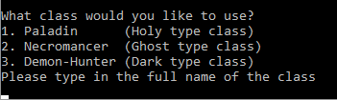

1. Dark
2. Holy
3. Ghost

The player will be able to select their class by inputting in the name of the class. Paladin for Holy, Necromancer for Ghost and Demon-Hunter for Dark

They follow a rock-paper-scissors method when inter acting with one another. Dark is weak against Holy but strong against Ghost. Ghost is weak against Dark but string again Holy. And lastly, Holy is strong against Dark but weak against Ghost. If the player where to encounter a monster of a class that counters them. They will both deal less damage and take more damage from the monster, and vis versa for the monster. If you and the monster are of the same class, then you will have no advantage over them and there will be no damage penalty or buff for either of you.

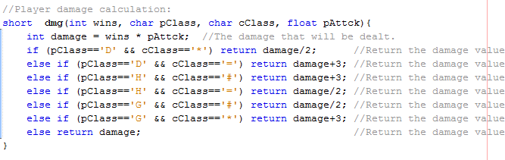

* 1. **Skill Setup:**

The skill setup portion of the code is mainly untouched from the previous game. The main differences are the starting numbers, and the fact that this portion has been broken into 3 functions. There is a big function which has the switch case. There is the display function which will print out the array. There is an over loaded calculation function one for health and one for the rest. (reason for separation will be discussed farther down).

The functions are:

void skill(int skills[], string skNames[], int points, int min, short n, short choice)  
void skTree (int skills[], string skNames[], short n)  
void skillcal (int skills[],string skNames[],int min,short choice,int &points)  
void skillcal (int skills[], string skNames[], short choice, int &points)

The user will enter a number (1 to 4) that corresponds to the skill they would like to add points to. A switch case is used to check what skill was selected.

Then, they decide how many points they will add to the selected skill. There is a do-while loop in place here, to ensure that the amount entered does not exceed the number of points available. The points are then added to the skill, and removed from the spendable points. Then one of three conditions could execute.

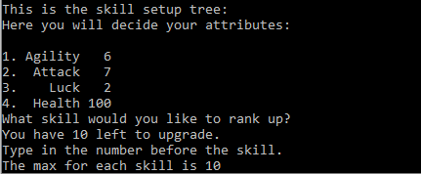

The first, the number of points in the skill fit into the range and no changes are done.

The second, there are too many points in the skill. The program will ask the user how many points they would like to remove. The removed point will then be added back to the spendable points.

The third, there are too few points in the skill. This will only happen when the user removes too many points. The skill will then just reset itself to its minimum amount. All the extra points in the spendable points will be cleared.

The program will continue to switch between condition 2 and 3 until the first condition is met. If else statements are used to decide which condition to execute. This will happen to all the skills except for the “Health” skill.

The “Health” skill has no range, so the number of points added by the user will be added to health.

**Sample code of the calculation function:**

Pseudo code for the process:  
User inputs the skill the would like to add too  
and the number of points to add.  
switch (input){  
case 1,2,4: (1, 2, 4 are individual cases)  
 Points are added to the selected skill.  
 Points are removed from spendable   
 points.  
 while points (are not in range){  
 if (skill points > range) {  
 Ask user to remove points   
 from the skill, and correct the  
 amount of spendable points.  
 }  
 else if (skill points < range){  
 Store the extra points then  
 reset the skill and remove the   
 extra points from the total   
 spendable points.

}

}

case 3:  
 Add the points health.  
}

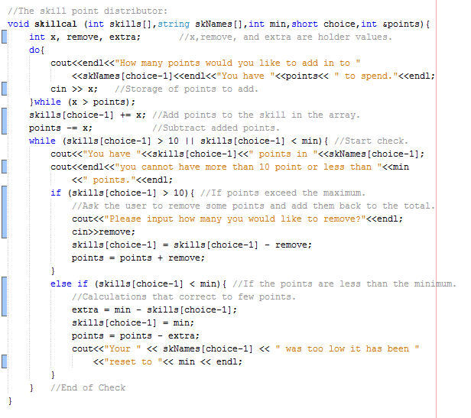

* 1. **Shop:**

The shop in this game follows the exact same logic as previous. However, there are changes. One is that instead of each of the 7 items having its own Boolean value there is one array. The Boolean array is parallel with a String array that contains the name of each item.

The shop exists in its own self-contained function. The player’s coins and health are passed though by reference, along with the Boolean and the String array, and the utilized size.

There are two shops located in the game. One at the very start of the game and one just before the final boss battle. The player starts with 15 coins. Here, the player can use the coins they collected throughout the game to purchase items.

To make the store function, I took advantage of the Boolean data type. The seven items are stored in the program as a Boolean array name it. All the stored values start off as true, ex. it[0] = true. If the it[n] is true, the store will present the item’s name. Else if the it[n] is false, the store will display purchased.

The user chooses an item to purchase via input of the number preceding the item’s name. I then used a switch case to check what the user input and determine what the user purchased. The Boolean value for the item would then change from true to false, ex. it[1]=false. Signaling the program that the item has been purchased and coins should be removed from the player’s wallet.

There is another items the player may buy which is the heal to 100. This “item” is not stored in either array. This item costs 10 coins.

In the case that the user tries to purchase an item that has already been bought, the program will not remove any coins from the play’s wallet. I accomplished this check using a ternary operator. The player may also leave the store at any time by typing in “10”.

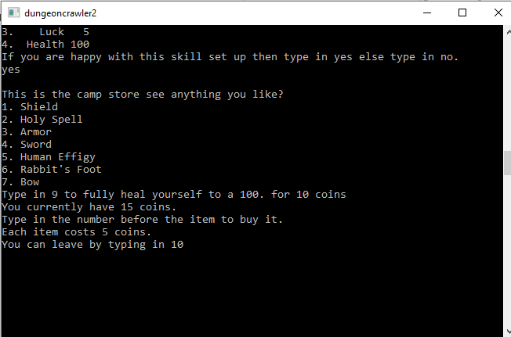

* 1. **Modifiers and Items:**

There are 7 items *Dungeon Crawler Version 2*:

* 1. Shield: Adds to health variable when they user uses their inventory.
  2. Holy Spell: Subtracts from the boss’s health upon user use.
  3. Armor: Immediately adds to the user’s health.
  4. Sword: Immediately adds to the pAttck variable.
  5. Human Effigy: Stores user’s health and can revive user, health = ehealth.
  6. Rabbit’s Foot: Immediately adds to pLuck variable.
  7. Bow: Subtracts from any enemy’s health upon user use.

How “upon user use” work will be explained later.

The use and implementation of modifier is the same as that of last game. Primary differences are the use of a modifier function, the removal of sneak from the game, and the pAttck calculation.

Modifiers are used throughout the game to calculate success rates of certain actions. Modifiers are integers in between 1 and 100; effectively changing them in to simple percent chance numbers. pAglty affects dodge chance, and pLuck affects loot and score amounts, (all of these will be discussed later).pAttck has been changed in this version of the game as seen below. It is not an integer in the range of 1 to 100, but it is now a float of exactly half that of the attack value found in the array.

Modifiers are calculated after the player has set up their skills and bought their items. There is a total of three modifier calculations. They are all based on the number of points allocated in each skill. However, if the player bought items that boost skills, 2 of these calculations change slightly.

The skills have certain limits to points to prevent the player from having too low or too high modifier values, this can cause them to be successful every time or never be successful in their selected action. As seen below each modifier is being multiplied by a specific number.

Passing in the skill values, the items and all the modifier values.

These are the calculations for the modifiers if the user purchased items 3,4, or 6.

These are the standard modifier calculations for the modifiers.

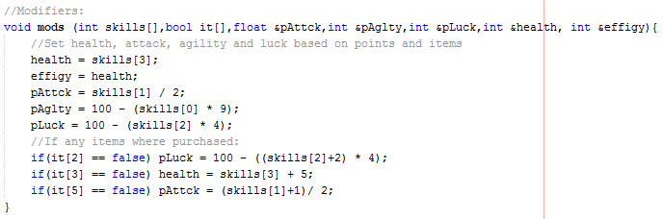

* 1. **Map, Movement, and Spawn:**

This part of the game received a full over haul. Nothing from the previous game remained. In the previous game the map and the movement was done through file I/O. However, this time it is done with arrays. Two two dimensional parallel arrays in fact. The first array is map[n][m]and the second is pmap[n][m].

The movement in the game is accomplished by user input. The user can input one of three movement options. Up, right, and left. Once they put in their movement the “P” on the map will move one position in the selected direction.

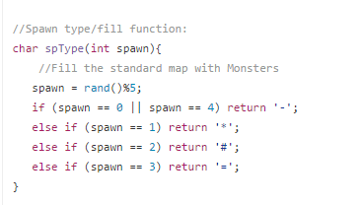

I will full explain the logic behind how this works.

First map[n][m]is filled in a function called crtmap, with “B”, “C”, “-“, “|”, in their standard positions. Then for every “- “, a function spType is called, which will replace the dash with: -, *, #, or =, based on a random number modded by 4. Each one of these represents a monster.

Second the map[n][m]is then copied onto pmap[n][m] using a for loop. All but for one single component of the pmap[n][m] will be replaced. The one that will remain is “P” and its location is store in the following location pmap[n][m]. The two variables inside the brackets are the location coordinates of the player. They start at prow=6, pcol=4, each time the player input a movement, the values are updated as follows: up subtracts one to prow, right adds one from pcol and left subtracts one from pcol. (Below shows the copy loop and the movements). If the player happens to try and pass through a | it will not work and reset all the prow and pcol changes. This map building process will happen every time they user inputs a move; there by creating a “dynamic” changing map with every turn.

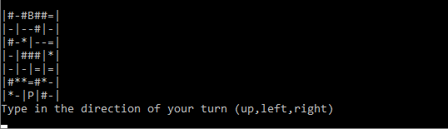

The copying code sample:

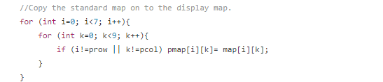

PseudoCode:

for (i=0 till i=6)  
 for (k=0 till k=6)  
 So long as i and k are not prow and pcol  
 pmap[i][k] = map [i][k]

The movement code sample:

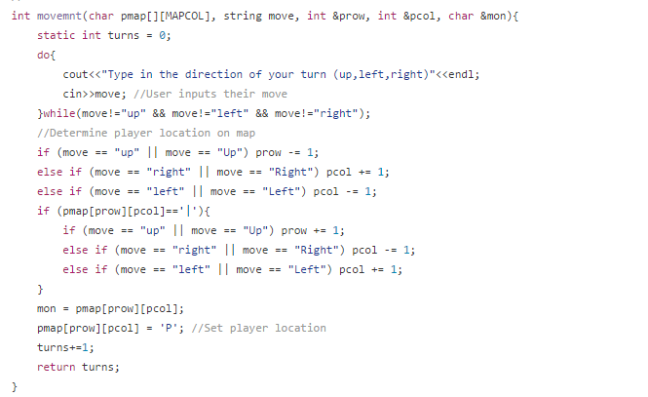

* 1. **Battle systems:**

This is another one of the systems that has been completely overhauled. Once the player encounters a monster, they are forced to fight. The sneak mechanic has been removed. The player can enter one of three action “attack”, “dodge”, and “inventory”.

The new system uses arrays and random numbers to determine who wins. The dice, there are two kinds of dice in this game that both the computer and the player has. Special dice and normal dice. Once the player has entered “attack”, the roll function is activated and fill 4 arrays with random numbers. The arrays are the player’s normal and special dice arrays and the monster’s normal and special dice arrays. Once the arrays, are fill all of them are sorted. Then the normal dice arrays are compared to one another, same goes for the special dice arrays. Each value is compared to its corresponding one in the array enemy’s array, ex. pDice[0] is compared to cDice[0]. Every time pDice[n]> cDice[n], pWins is incremented by one, and each time pDice[n]<cDice[n], cWins is incremented by one. If pDice[n]=cDice[n] both *pWins* and cWins are incremented.

Once all the dice normal have been compared, pWins and cWins are sent into function whowins. This function decides who wins the fight using the following rules:

If pWins>cWins player win and will deal damage to the monster.  
 else if pWins<cWins monster wins and will deal damage to the player.  
 else (pWins = cWins) both monster and player will be damage.

Damage number are dealt based on the previously explain rock-paper-scissors mechanic. The return number will be subtracted from the health of the chosen victim.

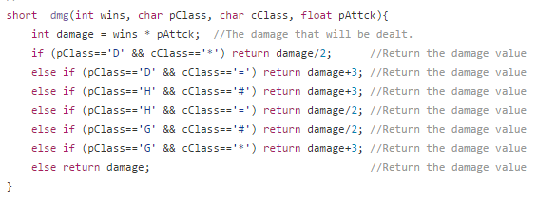

There is a counter that determines if the special dice are activated. If counter%3=0 then the dice are activated. They follow the same process as above but the only difference is that if spWinsequals 2 then the spAttck function is called. This function removes half the health of the monster. Else if the player does not achieve 2 wins spAttck fails.

If the user entered “dodge”, a function called isdodge is called. The logic of the function is as follows:

Pseudocode:   
read in int skills[], int ddge,int pAglty  
set ddge = to a random number  
if ddge>pAglty  
 return true  
else  
 return false

If the returned value is true, then the player has successfully dodged. After that the rolling process from before occurs, along with pWins and cWins calculations. Then ddge is set equal to another random number to determine is the player counter attacks successfully.

if(dChance == true && ddge>=50) successful counter attack  
 else if (dChance == true && ddge<=50) not a successful counter attack but a successful dodge  
 else Failed dodge and failed counter attack.

A successful counter attack will call the previously mentioned attack function and deal damage to the monster without the need of comparing dice. If the counter attack and the dodge failed, the monster gets to damage the player without the need to compare the dice

Lastly if the player typed in “Inventory”. A function called invtry is called. This function will allow the player use the items they purchased. The usable items are: Holy spell, bow, and the shield (What each item does was explain above). The user must input the name of the item they would like to use. Once the name is inputted it will perform its action and its Boolean value will be set to true.

At the end of the game the player is presented with the boss battle, this happens when the player has reached the “B” on the map. The boss battle is follows the same scheme as the other battle present in this game. However just before the battle sequence is activated an if statement becomes true and changes the values of two variables.

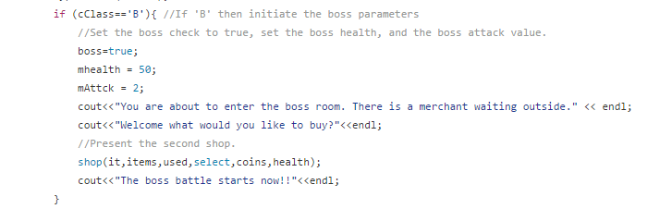

* 1. **Point and coin calculation:**

The player collects points through killing monsters, and they can also loot coins. These coins can be used by the player in the store. This looting function is done in a function called loot. In this function 2 arrays will be initialized and filled with random numbers in the range of 1 to 9. They are then both sorted, one with a bubble sort the other with a select sort. The player is then asked to enter a guess of a number between 1 and 9. This will be done twice once for extra gold and the other for extra points. The players guess and its corresponding array will be passed into searching algothim functions. One will be set to isbinary and the other islinear. If isbinary returns true then the player will get extra gold, but is islinear returns true then the player will get extra points.

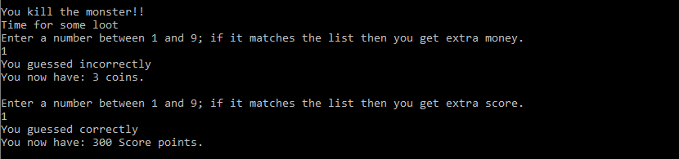

* 1. **High-score and the score screen:**

The high score has changed quite a bit. The core screen is only available to players who won the game, meaning they beat the boss. If the player loses then there will be no score screen displayed.

The high-score and determining if the player will get a high-score is done in the function named highscr. I took advantage of file streaming to make this work. The previous high-score and the name of who achieved it is stored in a file name “Highscore.dat”. The information is then read into variables called score1 and name1. Score1 is then checked again score, the player’s score.

If the score > score1 then *score* will be read into the file along with the inputted player’s name.

If the program will just ask for the player’s name and nothing will be read into the file.

Finally, the player will be presented a score summery. That include the player’s name that they inputted, their score, the number of turn that the game lasted for, and finally their winning skill set up.

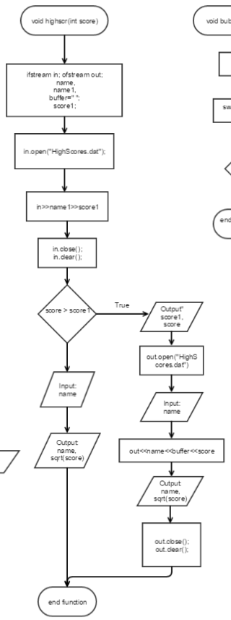

1. **Pseudocode, flowchart, and the code:**

Flowchart: <https://www.gliffy.com/go/publish/11357531>

If that does not work copy and paste this: https://www.gliffy.com/go/publish/11357531

If that does not work, try this: <https://www.gliffy.com/go/publish/image/11357531/L.png>

The code:

<https://github.com/Hassan-Farhat/FarhatHassan_48102/blob/master/Proj/Project%202/DungeonCrawler2/main.cpp>

The Versioning of the code:

<https://github.com/Hassan-Farhat/FarhatHassan_48102/tree/master/Proj/Project%202>

Pseudocode:

